IPAT 2023, # 3 Summer Newsletter

Meet Carol Craig artist and teacher from North Augusta, SC.
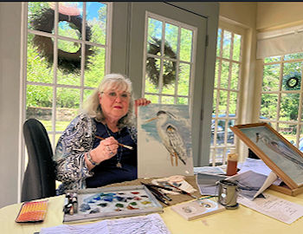
This August Carol will have been painting for 50 years and teaching for over 40 years. She is an artist from around the world. Her work is displayed in homes and businesses across the US and other countries. Carol designed and painted a bi-centennial plate that she presented at the White House in 1976. She was contributing artist for the GA Governor’s Mansion fine china project. Carol spent 15 days in Japan displaying her art at the cultural Center through the Sister City Artist Exchange for Augusta, GA. She is a charter member of the famed Artist Row, Past President of GWOCP, which she organized in 1991 as well as President of GA teacher’s organization [GAPAT]. She proudly displays her work permanently in several museums across the US.
Carol grew up in Elberton, GA, the Granite Capital of the world. The first flower she learned to draw was taken from the design on memorials manufactured by her Dad. In 1974 Carol began painting on china as a hobby and she has studied under Jeannie Hawkins while living in Athens, GA. She studied with many nationally and International known artists also.
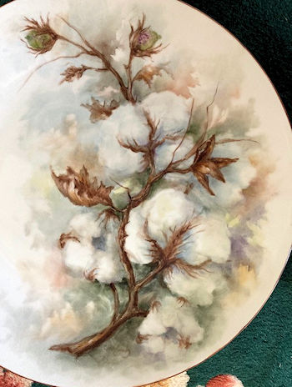
Philosophy of Her Art
Porcelain adds a functional quality of fine art and a challenge of designing subjects on a countless number of shapes and sizes. What better way to enjoy a beautiful piece of art than to be able to live and use it around you! Although I paint in other mediums, porcelain is still my favorite true love.
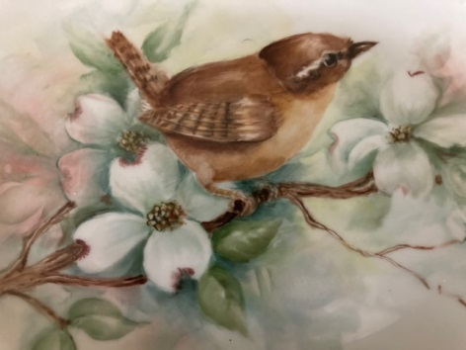
I’m a realist: I try to glorify God’s creations, especially flowers based on photos, accurate studies, or real things. Detail notes are essential as not to lose sight of the inspiration by the third or fourth painting and firing. Many hours are spent on even the smallest piece. Patience is a requirement. Tomorrow’s Heirloom.

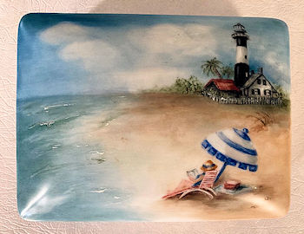
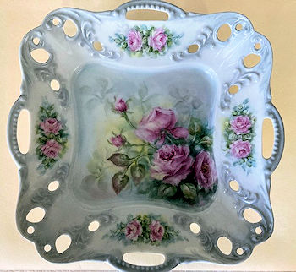
Currently Carol has 24 students. Two classes a week at my studio in N Augusta, SC, 4 regular classes a month out of town, Millen GA and near Savannah in Stilson. She recently taught a workshop on Cotton near Athens, GA, a favorite subject. She likes to paint grapes, hydrangeas, roses, palette knife painting on tiles, and anything my students wants to do. They are my inspiration and I never say “no”.
ccraignaug@gmail.com
706 799 7480.

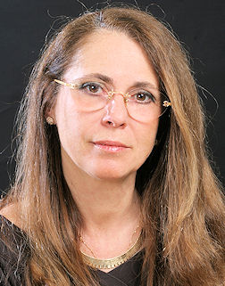
Simona-Marina has a classical and religious art education from Norway.
Before moving to France in 1996, her last icon exhibition was in Lillehammer, Norway, representing the Orthodox Church, as part of the official cultural programme in connection with the 1994 Winter Olympic Games held there. She discovered porcelain painting in 2009 and won her first 1st prize in the amateur level at the Salon International de Lyon in 2010. Since then, she has become professional and has won many international prizes, and her work has been published in many different porcelain magazines in a number of countries. In 2018, her work was published in Filipe Pereira’s “Celebrating the 60th Anniversary of International Porcelain Artists and Teachers”.
She likes to paint portraits, but her speciality is lace creations. She designs and adapts her lace to the pieces she is working on, with very intricate and miniscule details. Simona-Marina is known internationally for the delicacy of her work, and she travels a lot for teaching her technique. In 2015 she was Guest Artist at the 15th anniversary exhibition of the Porcelain Art Master Club (PAMC) in Tokyo, Japan.
In 2017, she had the chance to attend classes of porcelain making with Nancy Benedetti, an excellent ceramist and close friend, at Susan Painter’s school GA seminars by the Sea. She got fascinated by the art of porcelain making, and in 2018, after having gotten her own kiln; she developed her knowledge in a one-on-one seminar with the well-known French ceramist Anne Petite. From Anne, she started to learn the traditional Limoges technique. Simona-Marina likes to try out new ideas and techniques, aiming to create her own style. In the autumn of 2019, she presented her first collection of white porcelain at the PAMC convention in Osaka, Japan, and since then, she’s exclusively working on porcelain that she has made herself. Below is a design she created.

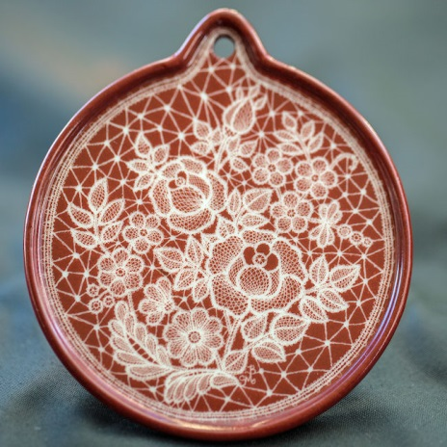
Stylized flower lace on Christmas Ornament Study
Materials used:
- Round ornament from Dallas China | - Medium universal MX 54
- Pompadour red color (or any other dark color) | - Clove oil
- Refillable mechanical pencil or wooden pencil | - Sponge for padding
- Toothpicks
Application:
Prepare the color with the medium MX54 and 1-2 drops of clove oil. Pad a VERY thin layer of pompadour red on the porcelain piece. Dry at once with a hair-dryer and let it dry for 2-3 days more, or as long as possible.
Tip: If you have any cheap dark color, prepare it like above, pad it on a tile (e.g. something you use for mixing your color) and apply the same process of drying. This tile can be useful for you for making exercises, before starting your work on the ornament piece.
1. Start the drawing of the model with the largest of the roses. The “stitching” of the rose petals is shown schema (1a).
2. Then draw the rose leaves on the left side of the rose, to help you decide the place for the second rose, which you then draw next. Continue with the rose bud and the rest of the rose leaves and stalks. See the schema step-by-step (2a) and (2b).
3. Continue with the stylized marguerite and its leaves. See (3a) for explanation of the way of working them.
4. Put all the small flowers, their leaves and stylized buds, see schema (4a). At the end, make the round border of the lace as shown in (4b) and connect all the rest of the elements of your lace with the bridges and their picots.
5. Verify carefully your work and fire at 800°C (con 016).
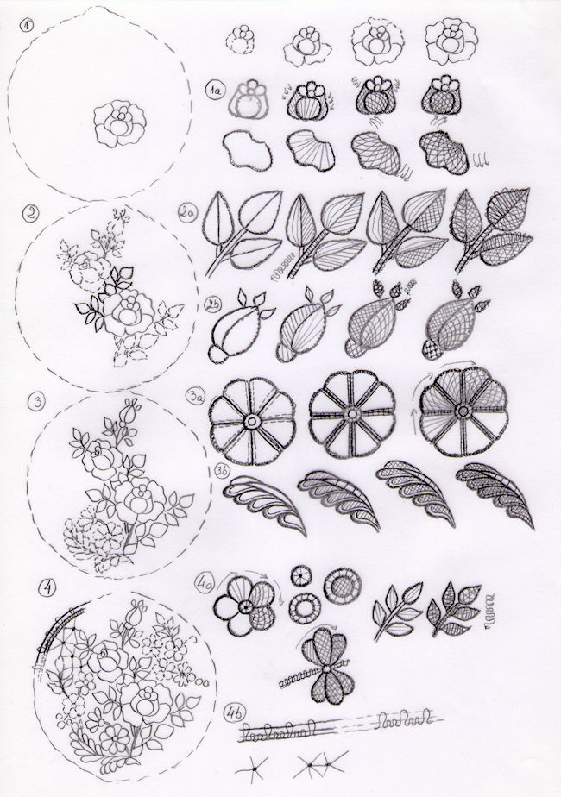
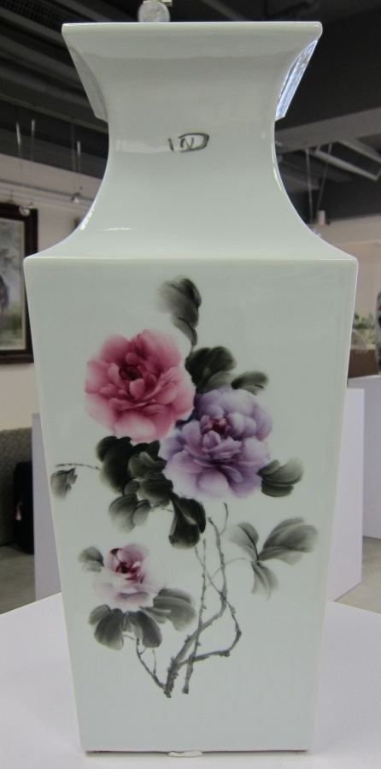
Finger Painting
Finger painting in the west is accepted as an art medium usually used by adults to teach art to children. The use of surgical gloves for safety is recommended. Sometimes sponges, cloth, and other tools are used to obtain a specific texture. By painting with fingertips, hands and fingernails, artists thought they could better capture the inner feeling and spirit of their subjects. It results in a real bond between the artwork and the artist which allows for some intricate blending not achievable with brushes. This technique forces the artist to work in a quick and instinctive way.

In China, finger painting is said to date back to the days of the Tang Dynasty during the 7th century and was popular in the 1700s. This vase is painted by finger except the very fine part like the birds’ beaks by small brush. The name of the artwork is “Four Seasons Like Spring” meaning the place has good weather, it is like spring all year round. This is done by an artist in Jingdezhen, China and is now a collection item in Century Gallery, Hong Kong.
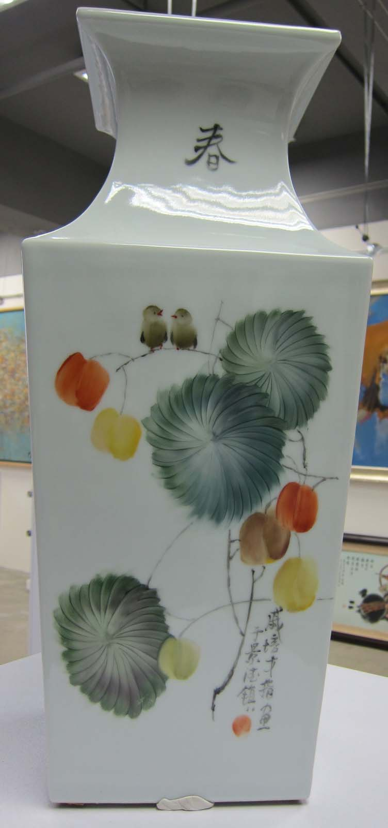
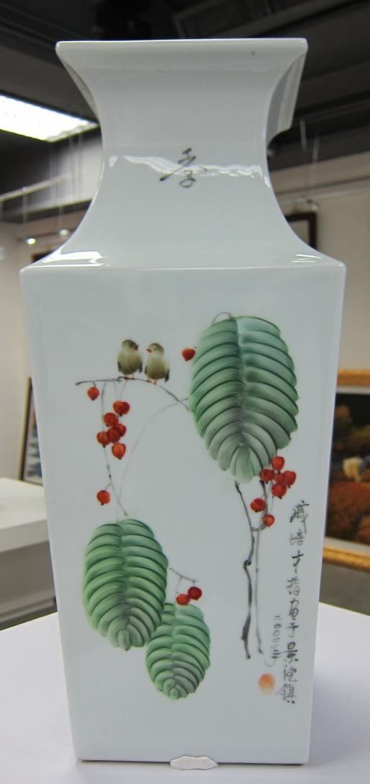
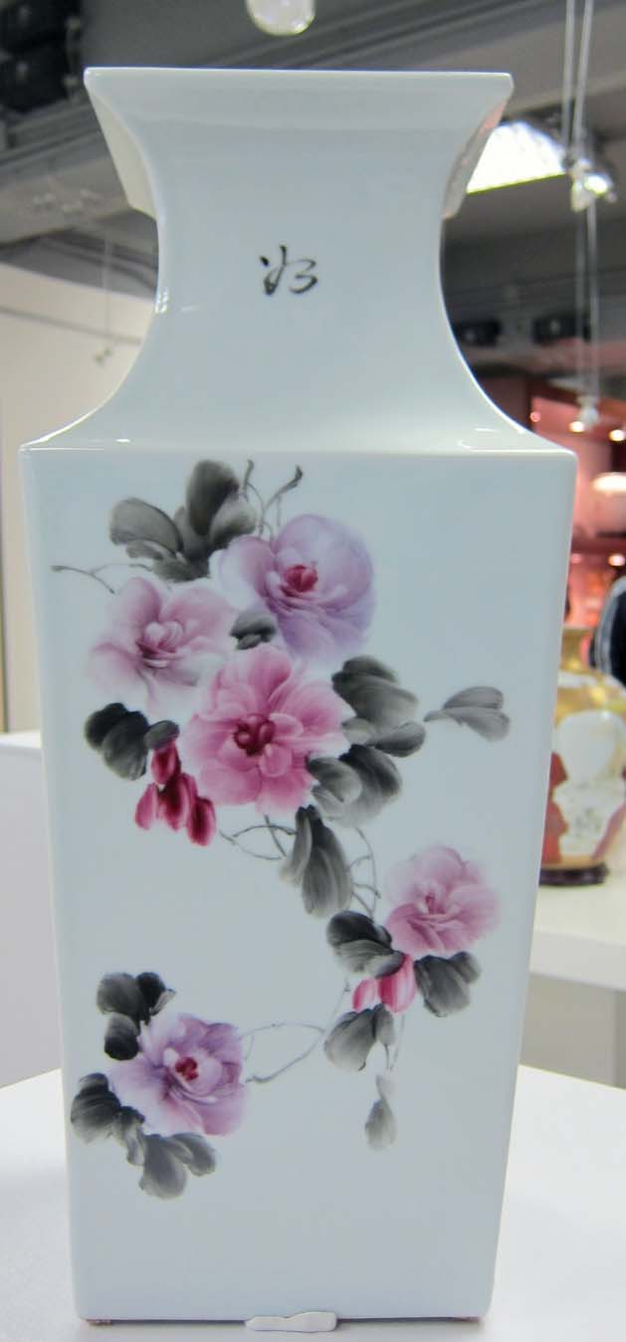
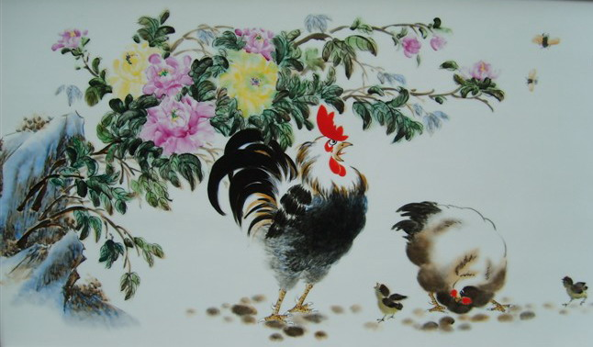
In China, any style and design, traditional to contemporary, birds and flowers, rivers and rocky mountains can be painted by fingers.

In this 36” x 20” size porcelain painting, my teacher Master Shi Yu Ming in Jingdezhen painted the roosters by brush, the peonies, leaves, and bees by finger.

The Finger Painting Method on flowers
1. Use the second finger to make the petals
2. Use the thumb to make the bigger petals
3. Use the last finger to make the smaller petals
4. Use the nail or small brush to make the stem and branches
5. Follow the lines of the finger and you know where to start and where to end or lift your finger. These photos are enlarged to show the direction of the fingers. These lines do not show up in the actual painting. The petals appear smooth and nice looking.

The following pages show the finger painting method step-by-step. There are many ways in China to paint by finger, this is one of them. In this demo, only black color was used, for actual painting, use multi-colors.
Do the main flower first. Start from the center of the flower with two finger strokes to make a heart shape. Add two ears to the heart and then add more strokes in the sequences as shown in the photos.
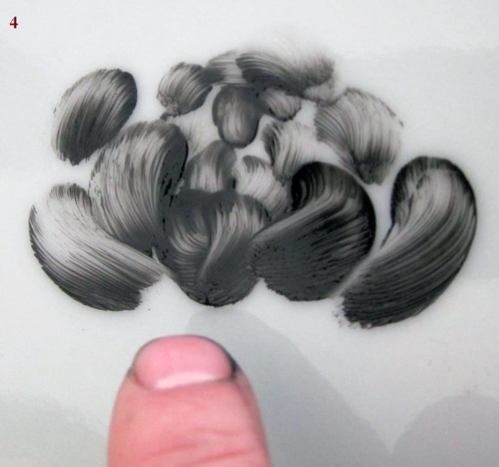
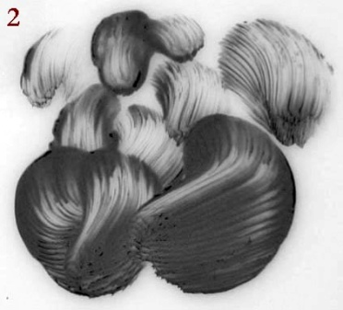
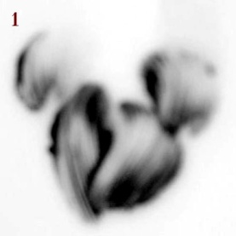
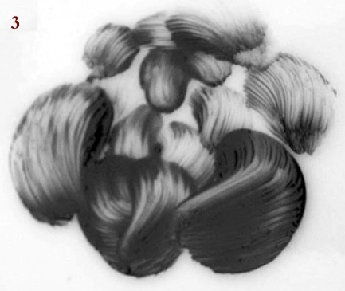

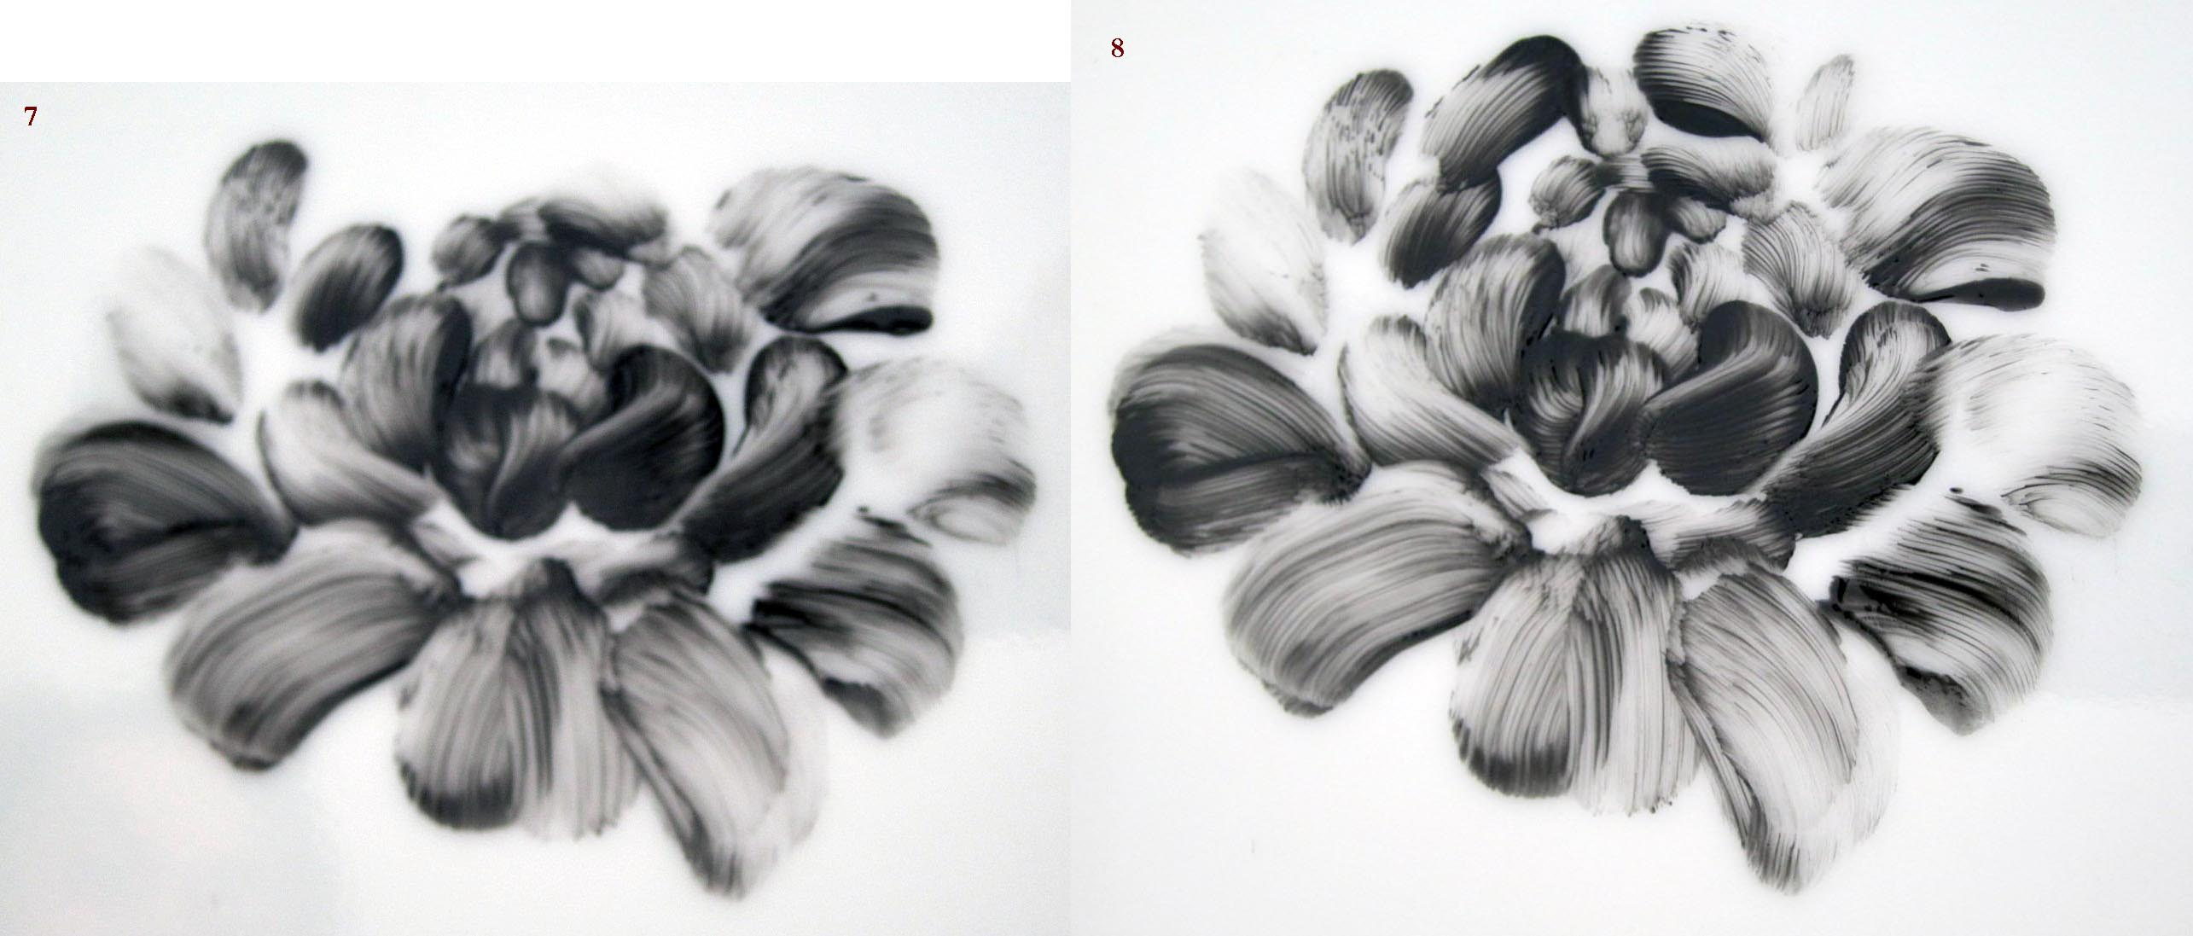
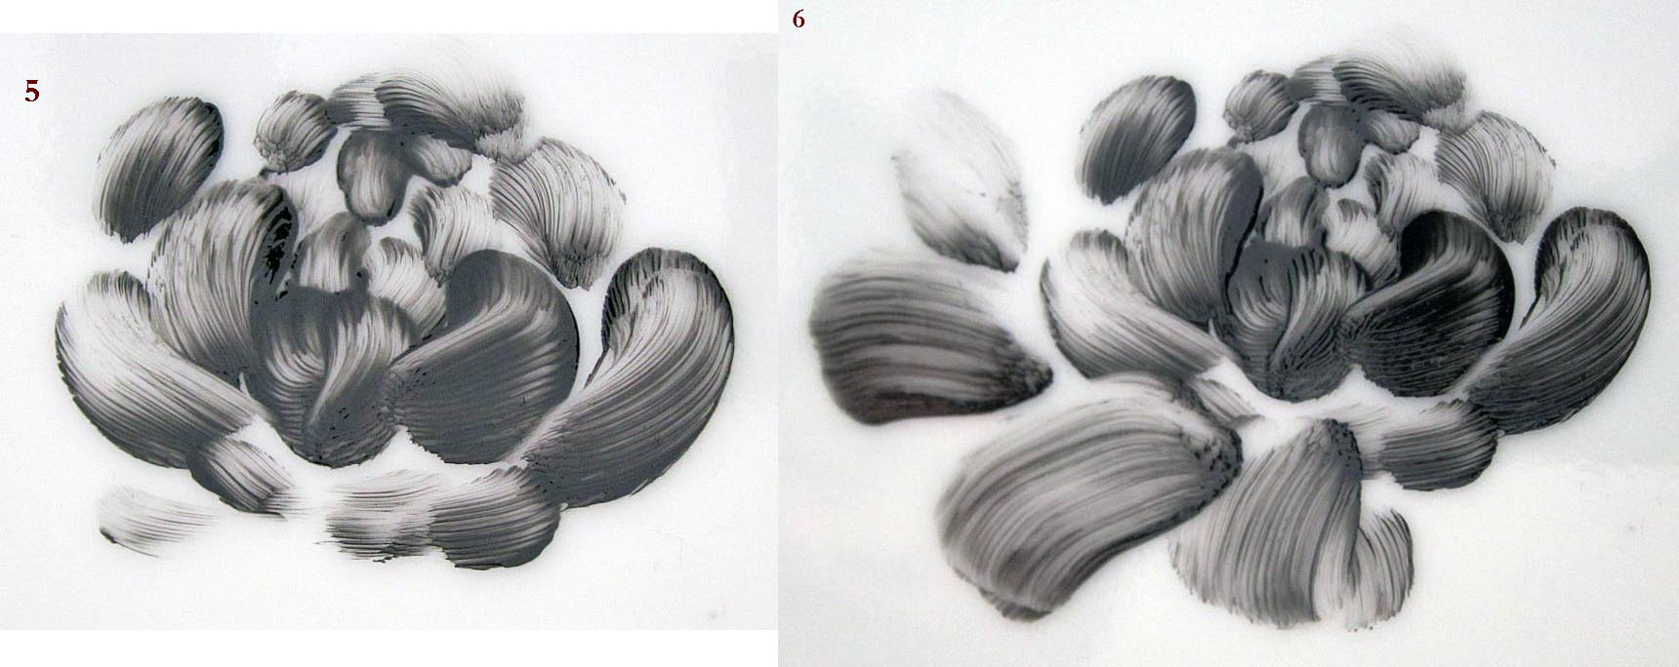
This is the main flower.
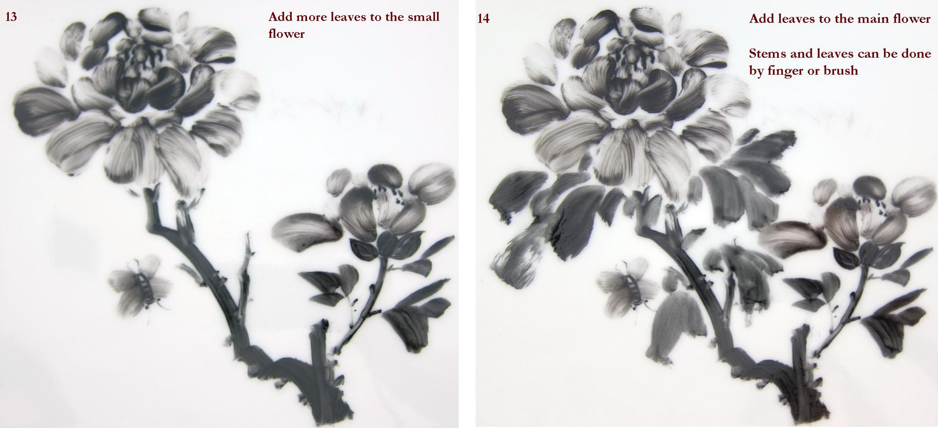
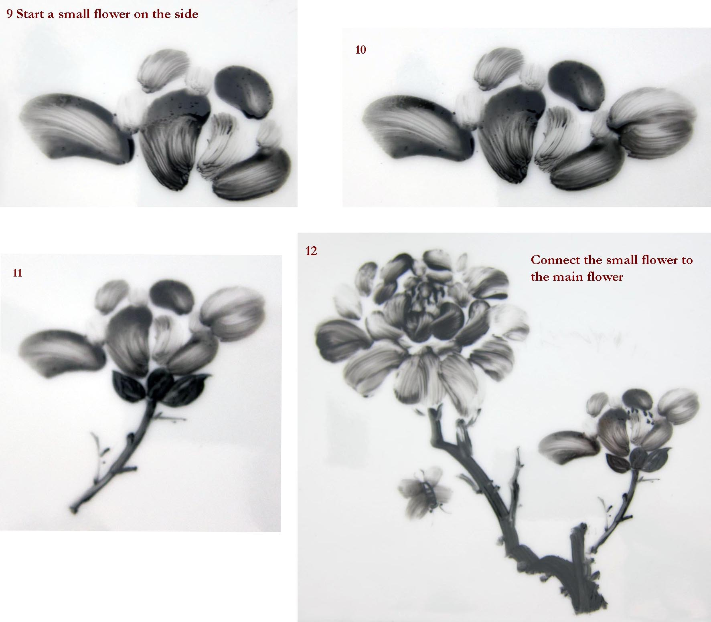
Paint the bee with second finger starting from the center and move to four directions as in the photo, then use small brush to add the details of the body, eyes etc.
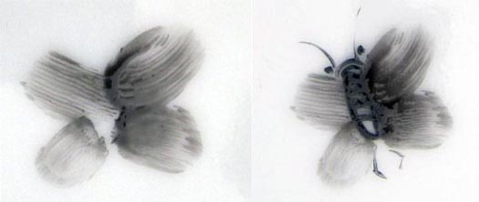

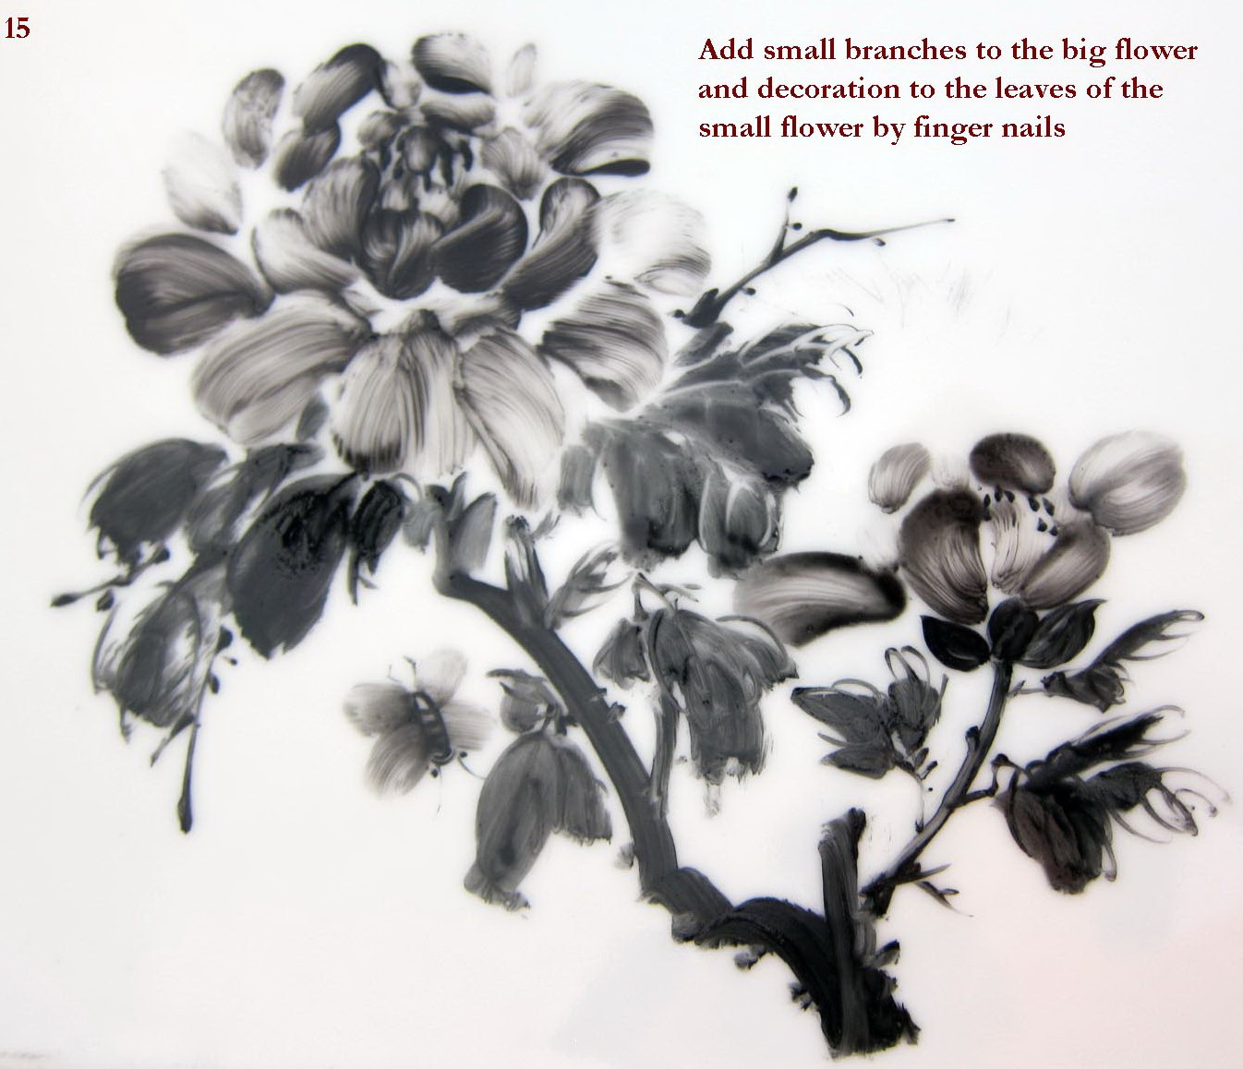

Porcelain colors and oils may not be healthy for skin contact therefore wear surgical gloves and clean your fingers thoroughly after finger painting. Tell your students to do so too.
Article and photos by Dr. Corinna Siu corinnasiu@hotmail.com.hk
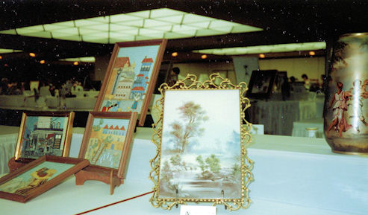
Looking Back to
An Older IPAT Convention.
Who can guess the year and where it was held?
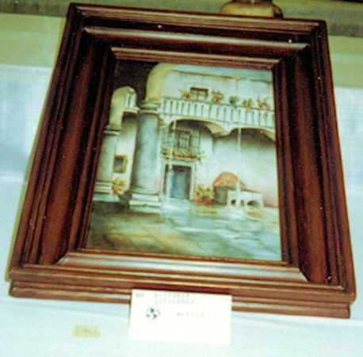
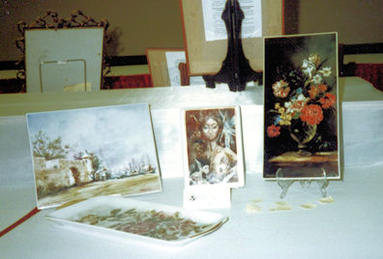
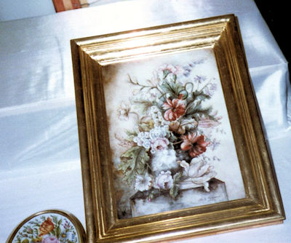

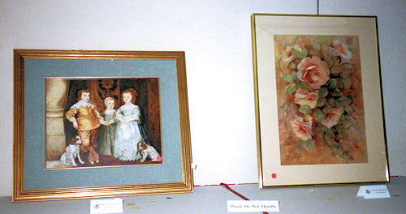
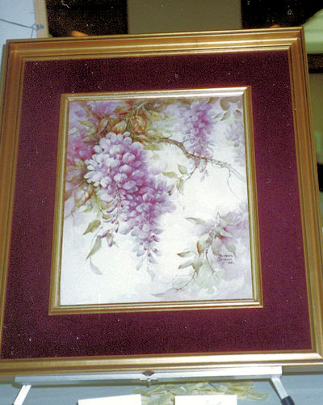

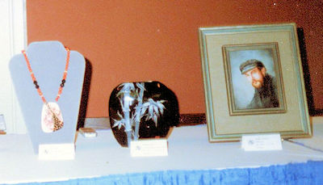

We welcome articles for the Newsletter and hope you will contribute to this, your publication. We like to see the different types of pieces being painted and taught from everywhere. Please send you article, photos and anything you wish to share to esp_ga@bellsouth.net

