Supply list for Relief Matt, Bright Pewter and Color Gel
By Rosemarie Borges
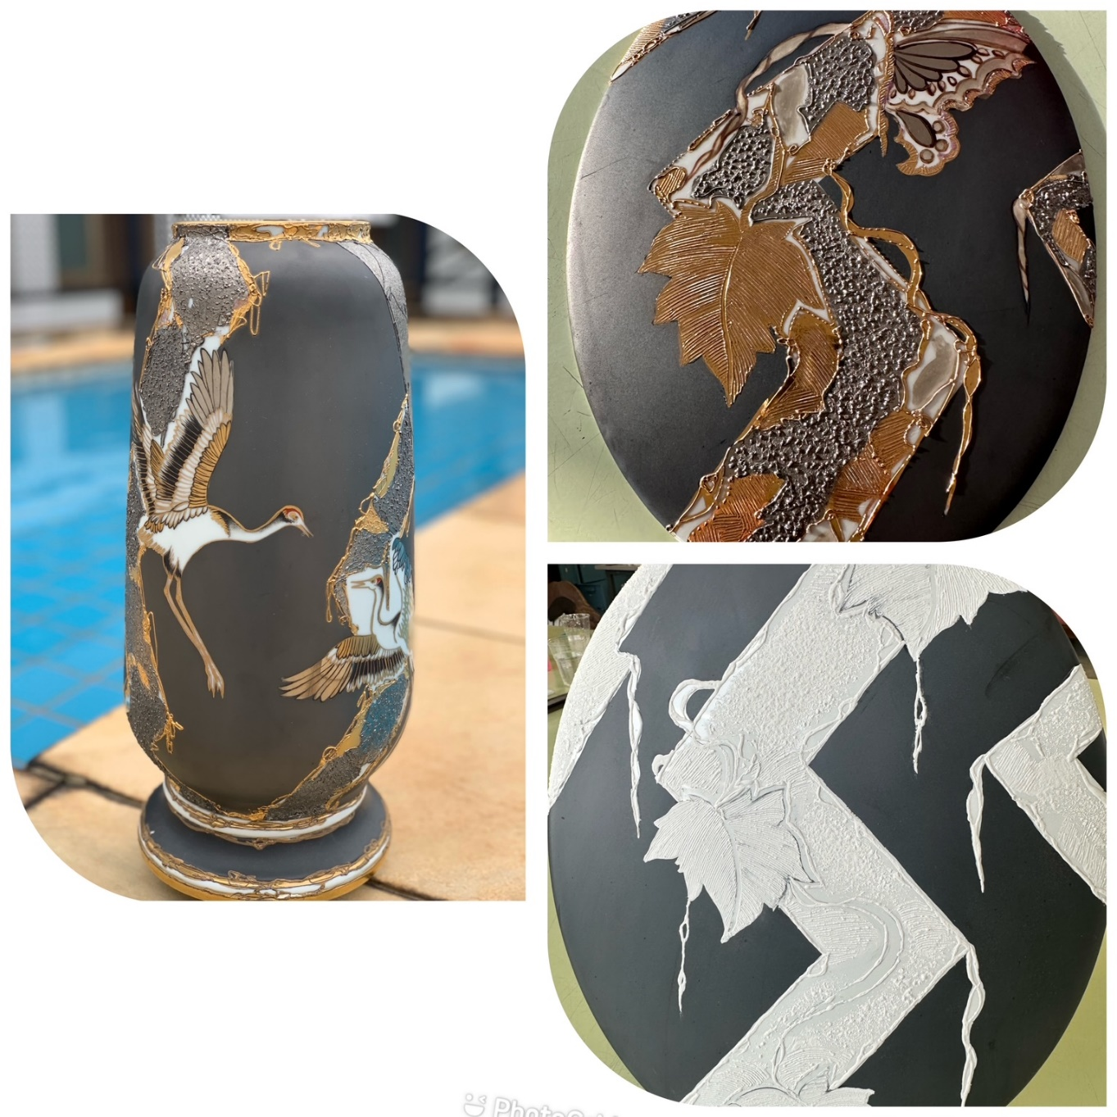

Following supplies list :
- plate (porcelain)
-pencil for porcelain
-Carbon Paper
- red resist and brush
-grounding oil
-Soft sponge
-Pewter (Color)
-nylon stoking
-cotton
- open medium
-relief medium
-Big Relief (Bright)(Brush #8)
-Mat relief
-porous sponge
-lice comb
-disposable syringe (cut needle)
-Mat Gold
-liquid bright gold
-platinum
-Color black mat (liner #2)

