“Impressive Borders” by Etsuko Hanajima
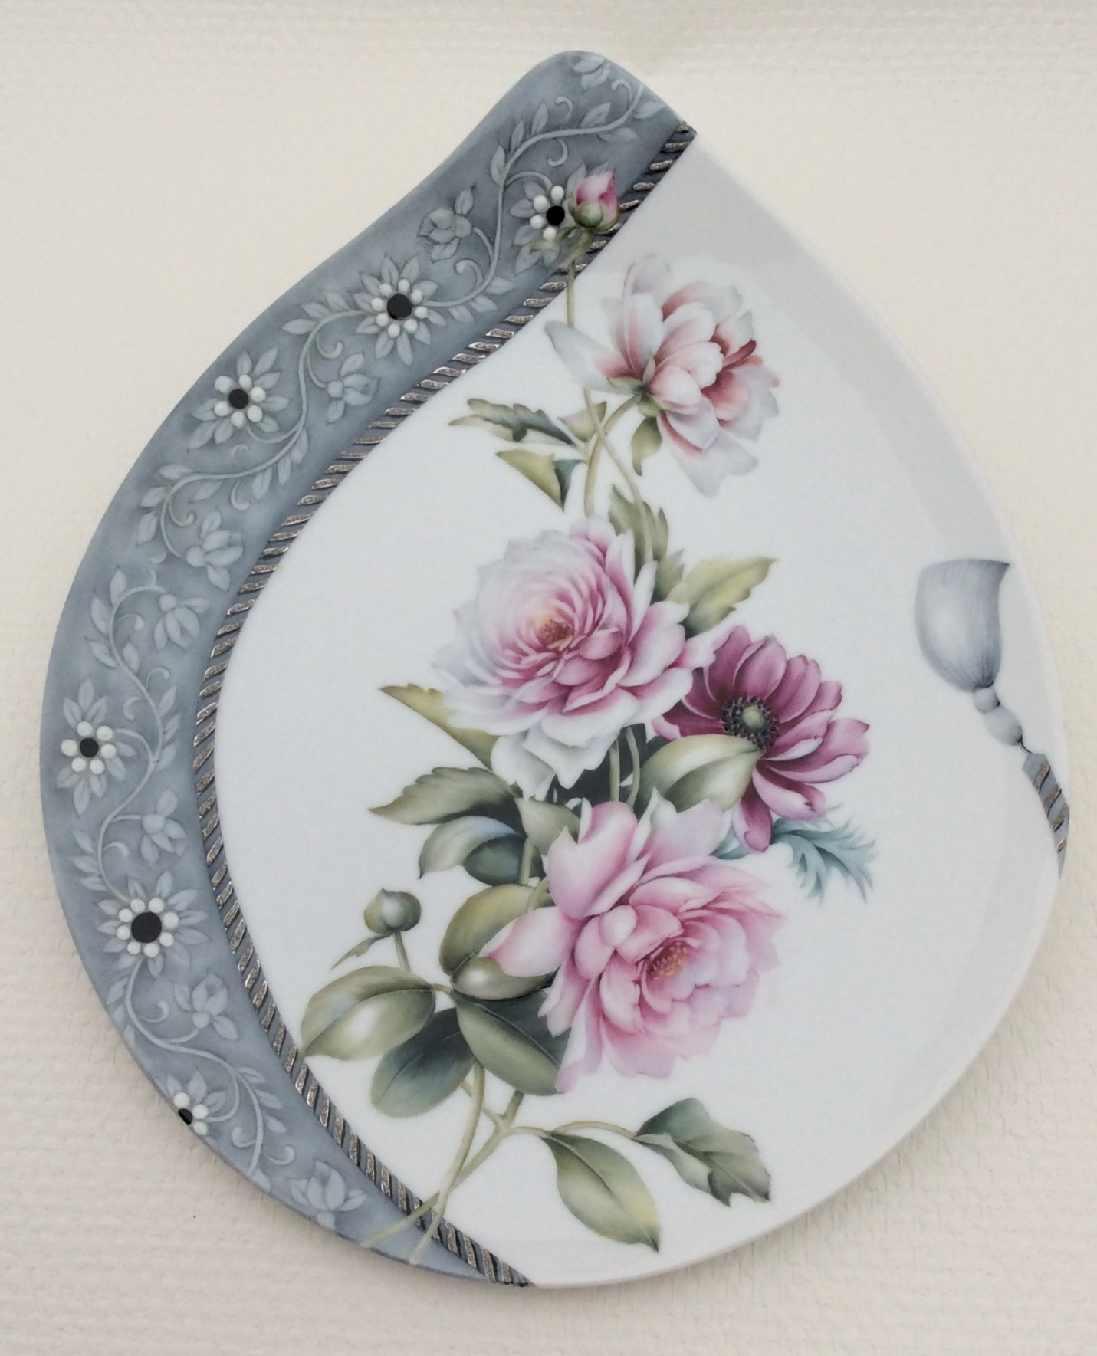

Supply List
Paint:
gray, black, rose maroon, metallic white paint
Materials:
transparent enamel powder, zircon sand
Gold:
bright platinum or bright gold
Oil:
pen oil (fast dry type is better), painting oil (slow dry type), balsam of copiba
Tools:
sponge, pen, wipe-out-tool
Brushes:
flat brush No.1.5, 2.5, liner brush, small brush for gold

