Stamped Solder Supply List
Dee Ann Blevins
Used as an embellishment on porcelain

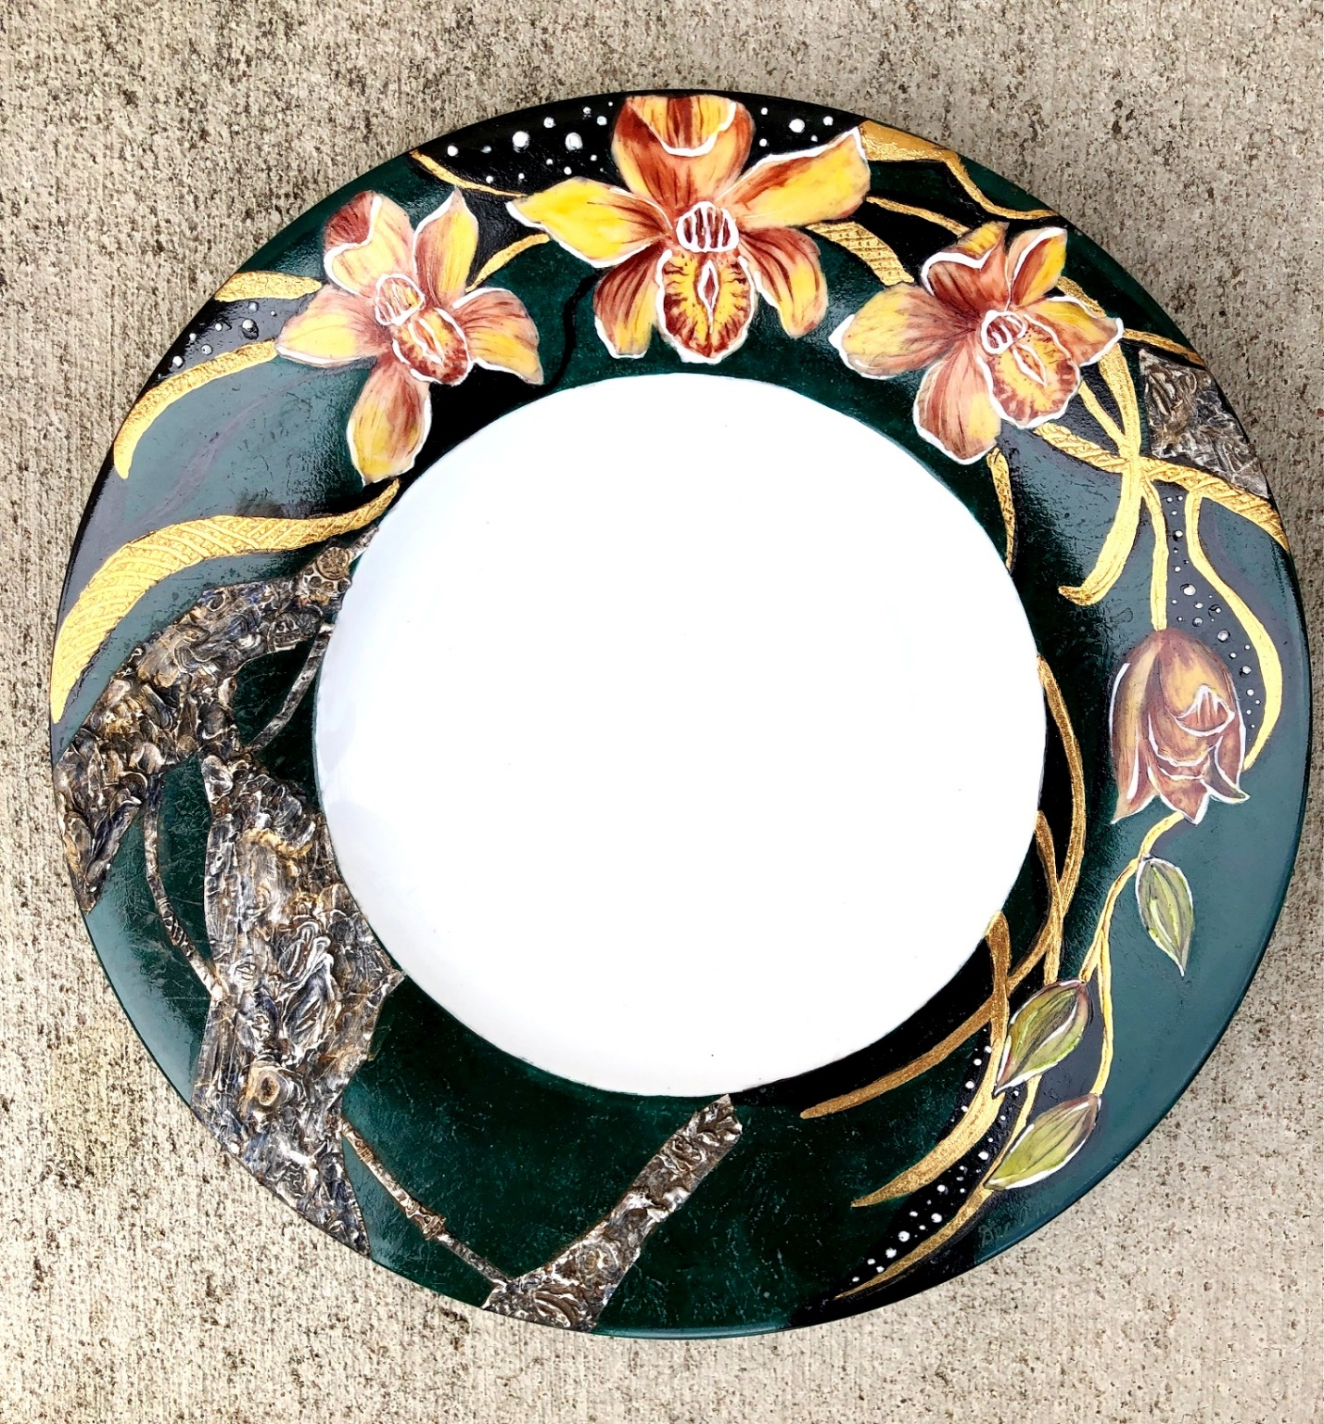

Stained Glass Supplies:
Soldering Iron with chisel tip
Lead free solder
Copper foil
Liquid flux
Patina, dark or black

Regular Supplies:
Red rubber stamps
Steel wool or emery board
Vinyl gloves
Ceramic tile
Clear acrylic brush-on sealer
Q-Tips
Paper Towel
Previously painted piece of jewelry or tile

