BOY & GIRL PLAYING IN THE RAIN
JANE WRIGHT
4200 Boulder Drive
West Des Moines, IA 50265
515-360-4502 janewright52@gmail.com
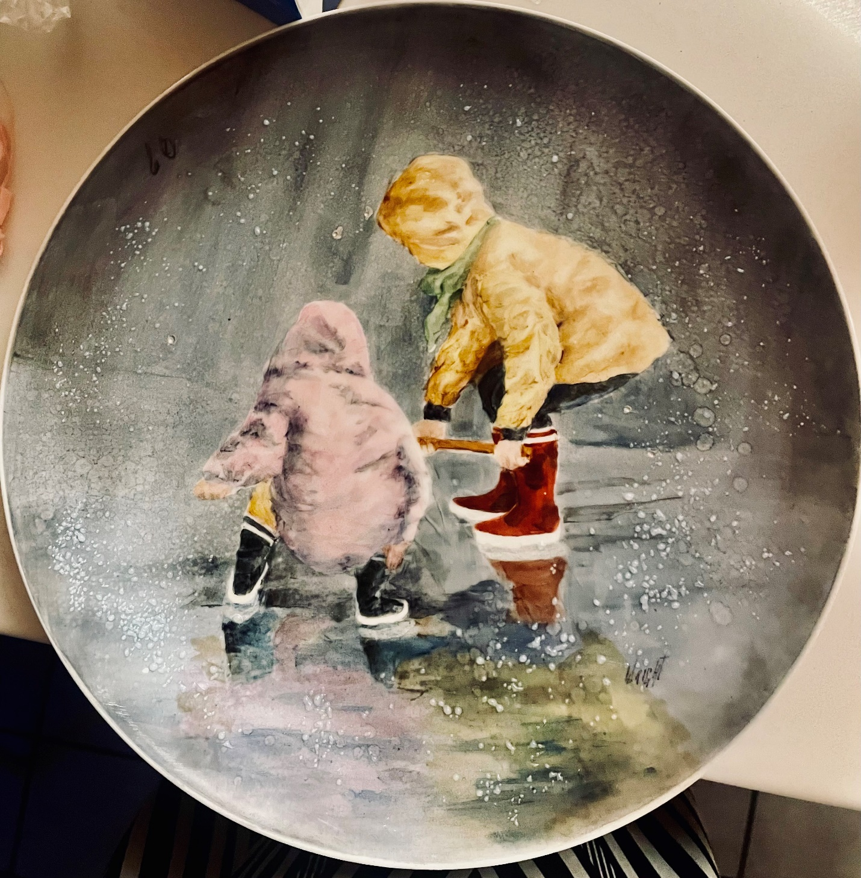

COLORS:
Yellow Brown Chartreuse Air Blue
Yellow Brown II Moss Green Royal Blue
Tan Antique Green Ocean Blue
Ruby Black Green Intense Black
Rich Red Gray Intense White
Violet of Iron Soft Rose Rich Brown
Mixing Yellow Ruby Turquoise

FIRST FIRE:
Resist both children. The reflection of children is painted using dry paint mixed with Water Base Medium (Yellow Brown, Royal Blue, Rich Red and Soft Rose.) The background is painted by mixing Gray with Silk Screen Oil. This dries very quickly. You can thin this mixture with turpentine. The yellow coat is painted with Yellow Brown. The scarf is painted with Chartreuse and Moss Green. The blue jeans are painted with Royal Blue. Be sure your coat and jeans have strong highlights. Red boots are painted with Rich Red. Blue boots are painted with Royal Blue. Pink coat is painted with Soft Rose. Gloves are painted with a mixture of Yellow Brown and Soft Rose. Fire .017

SECOND FIRE:
The yellow Coat is shaded with Yellow Brown II and Rich Brown in shadows and Tan in mid-tones. The blue jeans are shaded with Ocean Blue. The scarf is shaded with Antique Green and Black Green. The gloves are shaded with Violet of Iron and Yellow Brown. The red boots are shaded with Rich Red and Violet of Iron. The pink coat is shaded with Gray and purple (Ruby and Royal Blue). Blue boots are shaded with Ocean Blue and Intense Black. The reflection in the water may need more color. It can also be shared with gray. Fire .017

THIRD FIRE:
The background is shaded with gray and Turquoise, Royal Blue and Ocen Blue. Intense White can be used to make background stronger with reflection. Fire .017

