Painting Trees
By Shirley Weston

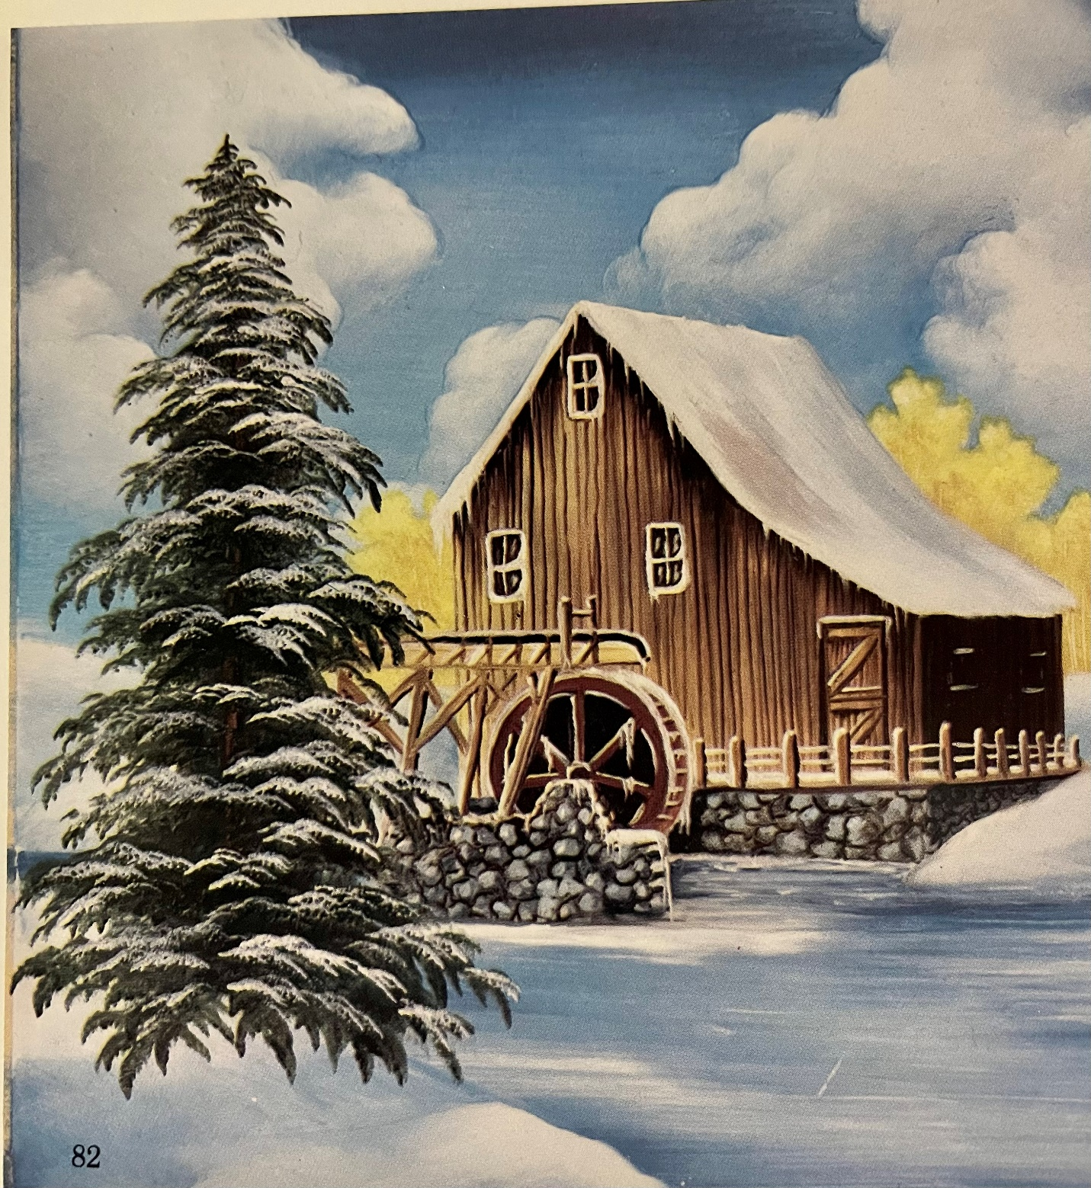

Colors for the trees: warm gray, rich brown, black. A strong bright chartreuse color, a medium green, Meissen green is excellent, and a rich dark green, not black green! Not that dark. Something that will shade, but not kill the colors. Royal green is good, However, do not use it if it has a lot of blue in it. Do not use a brown green, that is a lifeless color.

If you are doing Fall use bright yellow red, pompadour and maybe add a touch of violet of iron to the pompadour. Another good color for fall is 3/4 Ruby and 1/4 pompadour mix. This makes those deep red leaves.

For Spring leaves use a strong pink or rose, and a Ruby.

Types of brushes used…at least 2 sizes of filbert brushes. These are synthetic but soft, an 8, 10 and 12 which will cover any size needed. Size 6 if painting thimbles.

Some type of round brush that can be used to dab paint. A brush that is soft but strong, not like a Dresden round brush, nor watercolor round. Stiffer than those, more like a deer foot that is longer haired and rounded. Sponge with holes in it or sea sponge

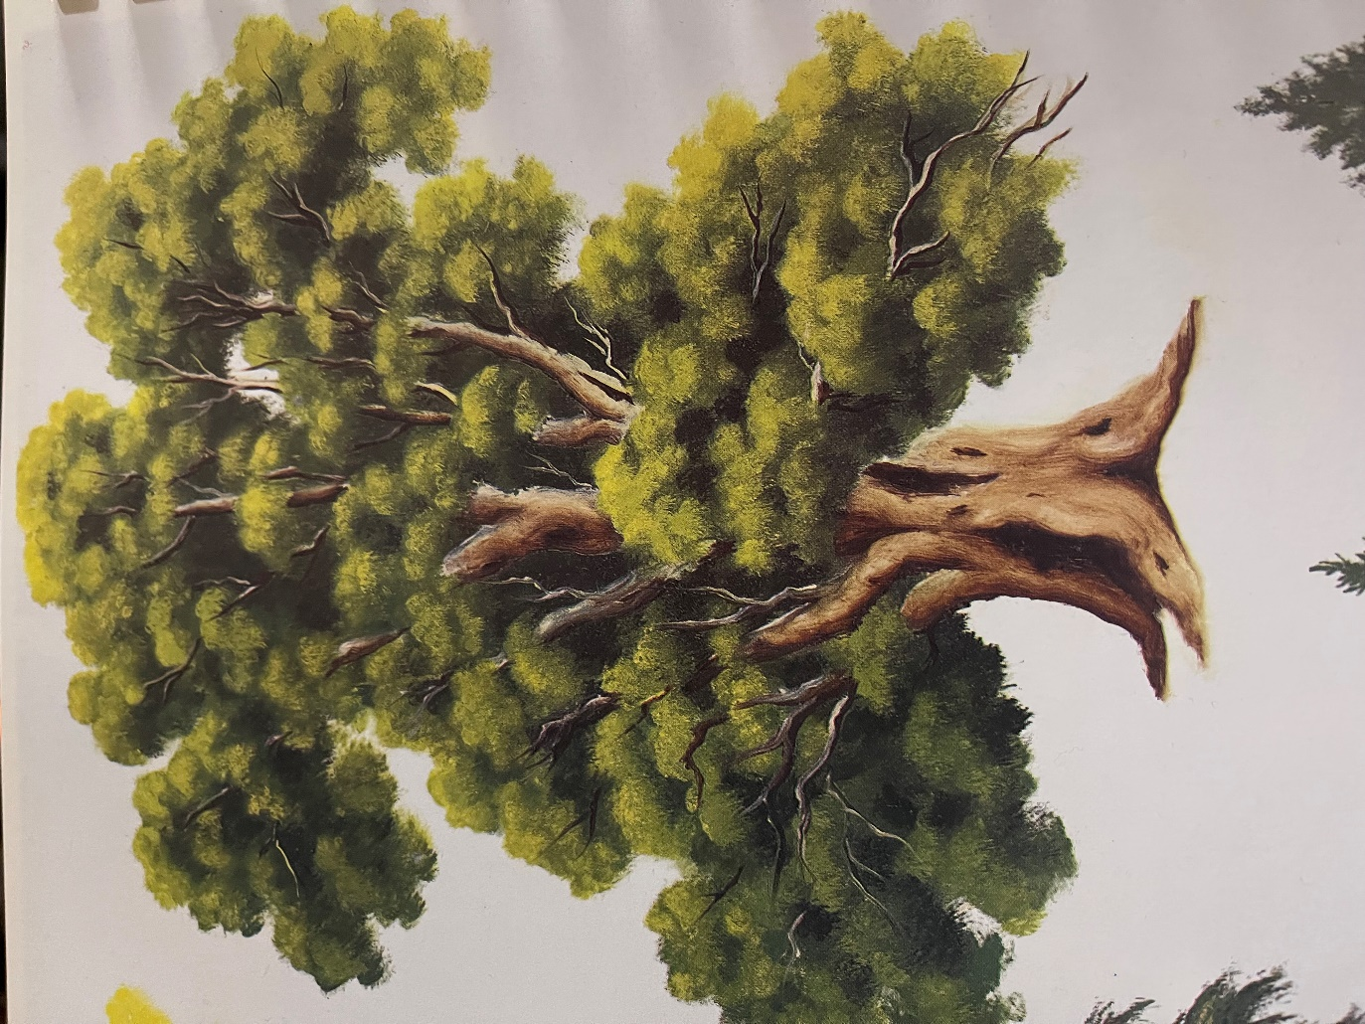
More Trees

